Assignment 13
1️.Write a UNION of two queries that displays the names, cities, and ratings of all customers. Customers with a rating of 200 or higher should also display the words “High Rating,” while all others should display “Low Rating.”
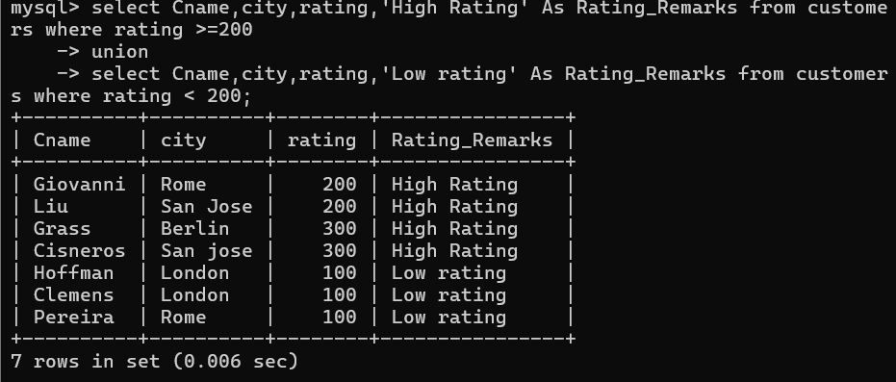
2️. Write a command that lists the name and number of every salesperson and every customer who has more than one current order, and sort the final combined list alphabetically.
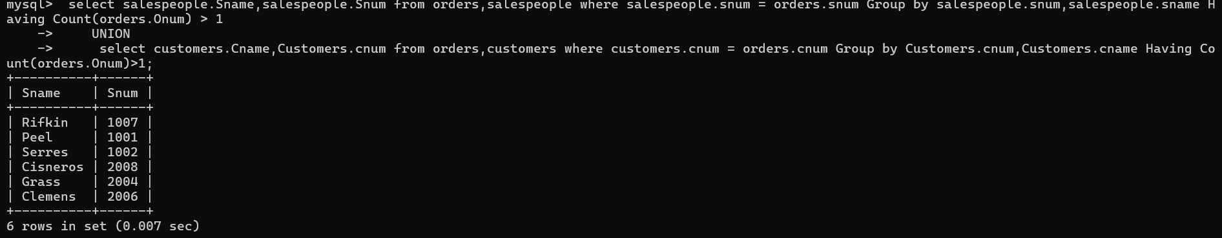

3️. Create a UNION of three queries:
- The first should select the salesperson numbers of all salespeople in San Jose.
- The second should select the customer numbers of all customers in San Jose.
- The third should select the order numbers of all orders placed on October 3.
Duplicates must be kept between the second and third queries, but any duplicates between either of them and the first query must be removed
